**Steps to set up Automation Framework:**

1. Install Java
2. Set JAVA_HOME
3. Install IntelliJ IDE
4. Import project from Bit bucket
   1. Clone git repo in local machine
   2. Open IntelliJ
   3. Click New 🡪Project from Existing Source
5. Open Build. Gradle and refresh Gradle file to update all required dependencies

**Steps to run Scripts:**

1. Gradle automatically compile the code
2. In Select Run/Debug Configuration, select runner file

Note: In feature file for each scenario tagging available, we can run scenario from runner file on the basis of tag.

1. Then Click on Green play icon

**Folder Structure:**

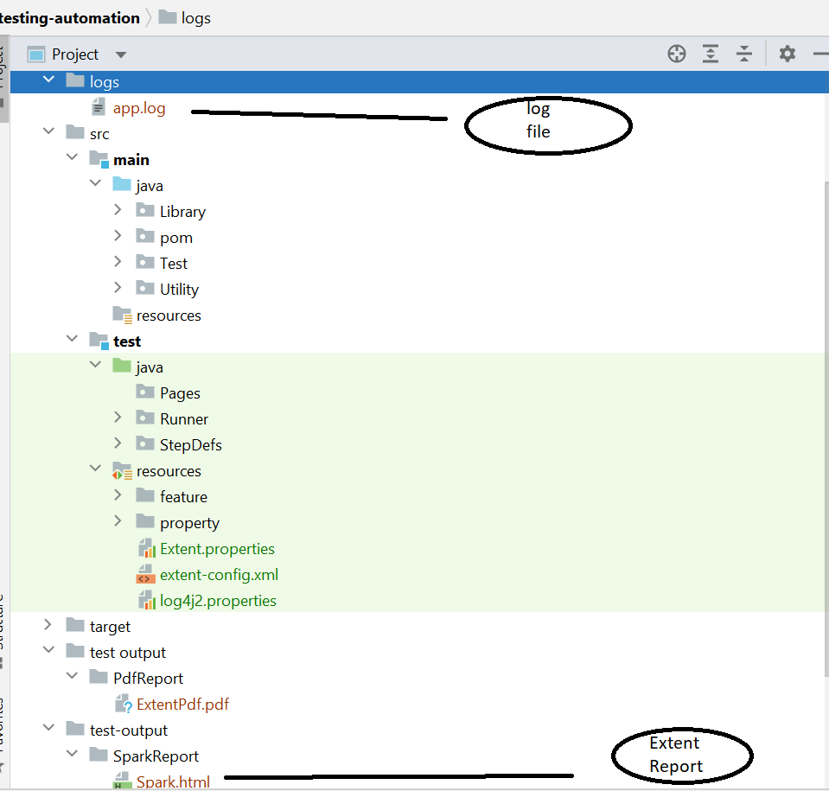

Sample log file:



Sample Extent report:

